Nate Riggs

CS – 320

Southern New Hampshire University

12/14/2024

Project Two
Summary
As I became more familiar with creating unit tests, my testing approach became more robust and aligned closer and closer with the software requirements. When first developing the Contact Service feature and testing the Contact.java base class, I was only testing to see if a particular attribute of a Contact was a certain length such as the first name being 10 characters or less such as in the following snippet: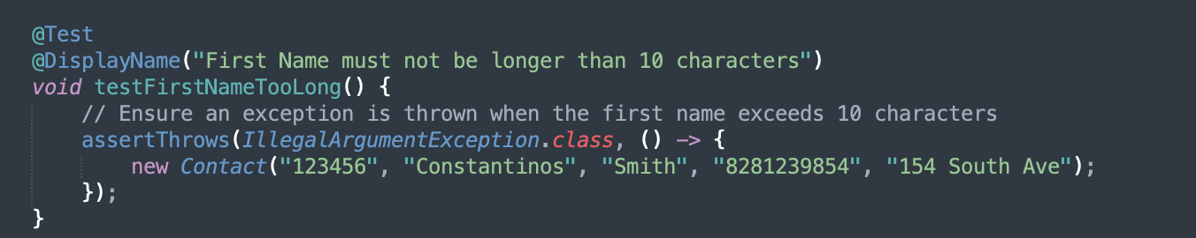
While this did meet one requirement, I was not testing to see what happened if the software tried to set a first name that was null or just blank so, while my software might have met the requirements overall, I did not test for those specific requirements. As I got into later aspects of development and testing, my testing approach evolved. I would create tests that would test to see if an object was created with a valid or invalid field and would also test the setter and getter methods for that particular field to ensure that I was testing every single permutation an object could be created such as testing for a generic appointment creation, testing to see if an appointment’s description is null, testing with a valid description, and even breaking the system down even further and testing the individual setter method for the description to ensure that that would be working correctly.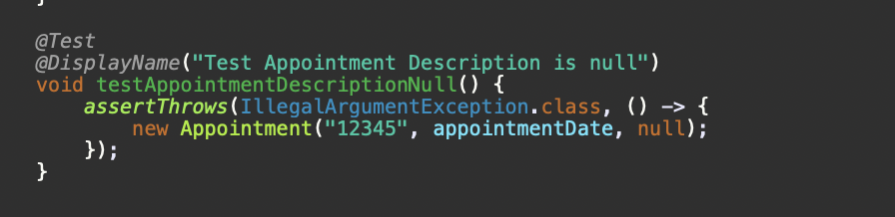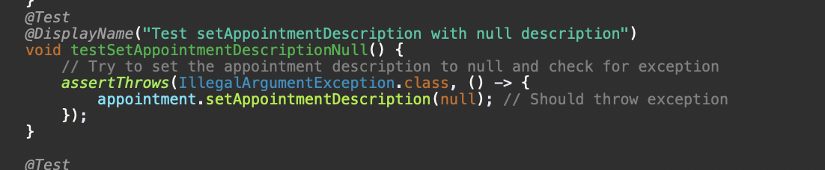
When developing my tests, I strived for 100% for the class that the Test class was testing. Depending on which class was being tested, this could involve dozens of different tests to ensure that every possible permutation of the constructor or class methods was being tested thoroughly. As an example, because the Contact class had multiple parameters that had their own requirements, I created and tested upwards of 16 Junit tests to ensure that I hit 100% coverage for that class.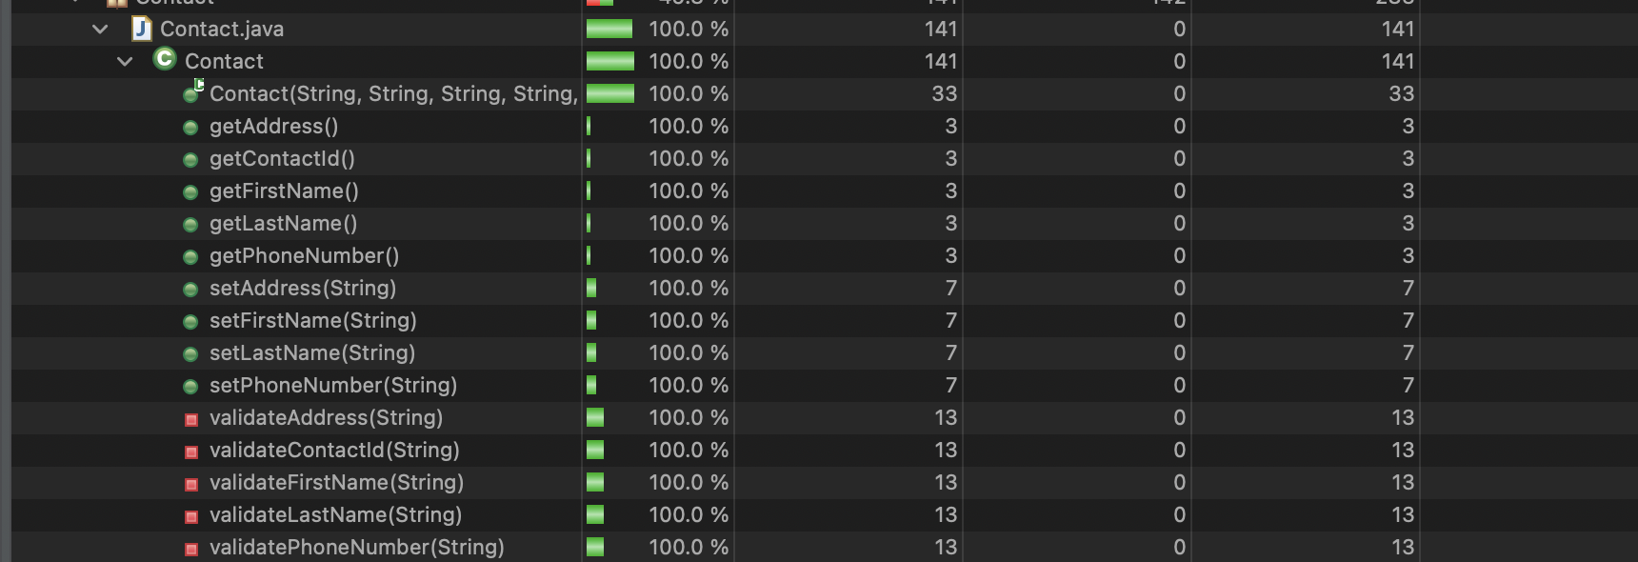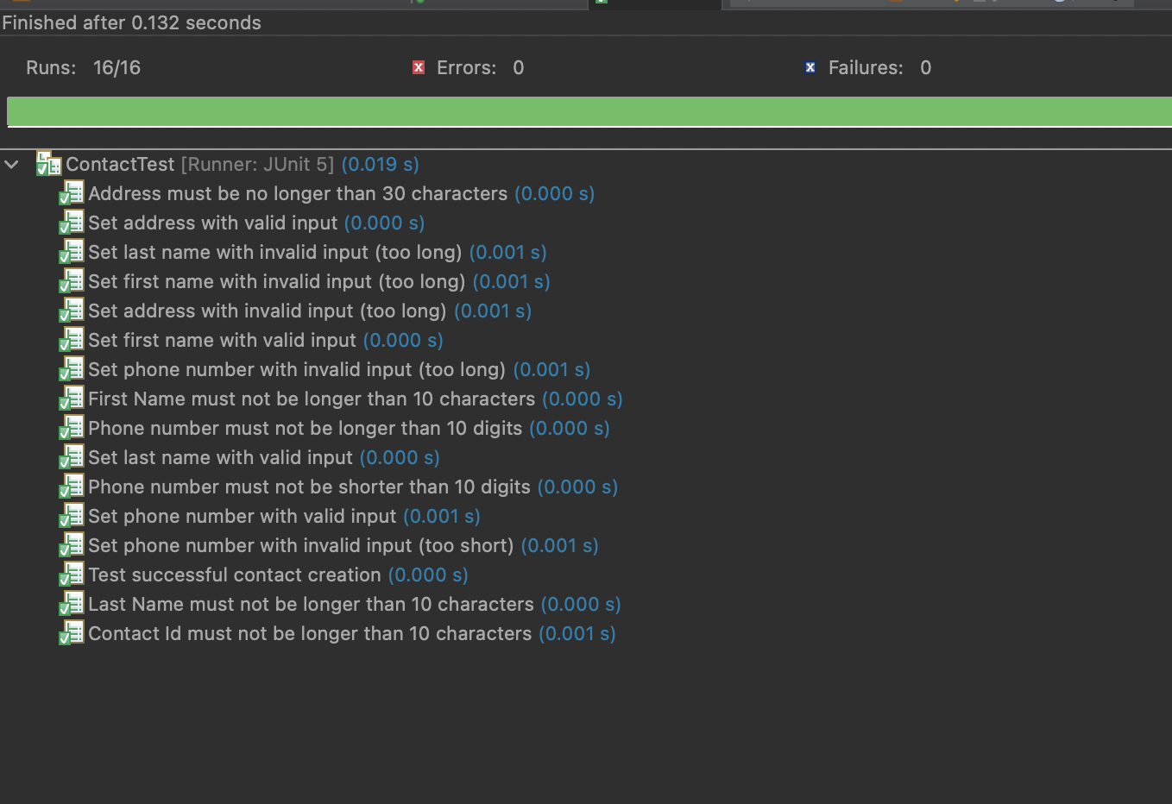
In comparison, the TaskTest class needed 9 tests to achieve 100% coverage of the Task. Class and the AppointmentTest class needed 11 tests to hit 100% coverage of the Appointment class. Because of hitting 100% coverage, I feel that my tests were effective because every aspect of the base class was being tested.

I worked to ensure that my code was technically sound by testing every method through a series of comprehensive unit tests. Each method was tested with multiple inputs depending on the object’s attribute to ensure that every permutation of that attribute would be tested to ensure that nothing would slip through the cracks. An example of my code being sound would be about the Appointment and AppointmentTest classes and specifically to an appointment’s date. The requirements stated that an appointment’s data was required, could not be null, and could not be in the past. To make sure my code was sound, I created a function that would be used to validate the appointment date, validateAppointmentDate(), that would throw an exception if the appointment date passed into the function was before the current date as seen in the screenshot:
// Check if the Appointment date is null or in the past
public static void validateAppointmentDate(Date appointment date) {
if (appointment date == null || appointment date.before(new Date())) {
throw new IllegalArgumentException("Invalid Appointment Date");
}
}
When testing the Appointment class, I tested what would happen when setting a new appointment date that was null, that was in the past, and that was either in the future or at the current time as seen by the following screenshot:

@Test
@DisplayName("Test setAppointmentDate with past date")
void testSetAppointmentDateInvalid() {
Calendar calendar = Calendar.getInstance();
calendar.add(Calendar.DAY_OF_YEAR, -1); // Add 1 day for a past date
Date pastDate = calendar.getTime();

// Try to set the appointment date to the past and check for exception
assertThrows(IllegalArgumentException.class, () -> {
appointment.setAppointmentDate(past date); // Should throw exception
});
}
Doing this would ensure that when setting an appointment, a user would have to put a date for the appointment and couldn’t accidentally set the appointment date for the past. I would implement similar functions and tests throughout the different services.
To make sure that my code was efficient, I utilized early exists throughout various methods to ensure that unnecessary iterations of for loops were not executed, ensuring that the method would only run for a certain amount of iterations but also ensure that there would not be any potential data loss by things getting deleted when they shouldn’t have been. I would also utilize @BeforeEach and @AfterEach annotations for my testing classes to ensure that contacts, tasks, or appointments are only being created or deleted at specific points during the testing.
Reflection
I used a couple of different software testing techniques throughout the development of the project. One testing technique that I used was Static Testing and more specifically Code Reviews. I would review my code thoroughly both as I was originally developing it to ensure that I was meeting the requirements and then again if/when one of my Junit tests would fail. When a specific test would fail, such as the various tests to delete a contact/task/appointment, from the list, I would search back into my code and look at the logic for that specific method to ensure that the item was being deleted properly and then implemented another scan through the list to ensure the item was deleted. I also performed Dynamic Testing and I did this by implementing a variety of unit tests to ensure that the different services met the requirements that were asked of those services. While I did perform extensive amounts of unit testing and code reviews, I did not utilize other software testing techniques such as integration testing and system testing as much as one would like. If I had worked to develop the software further, such as making a new object that would utilize aspects of all of the other services like having a task assigned to an appointment for a contact, then I would use more integration testing to ensure that every aspect of the application would work as intended and all of the different methods and objects would work together. I performed minor system testing to ensure that everything met the requirements of the software.
Code reviews, unit testing, integration testing, and system testing all serve distinct purposes in software development, ensuring quality at various levels. Code reviews focus on improving code quality, maintainability, and adherence to standards through collaborative inspection. Unit testing validates individual components in isolation, encouraging modular design and catching bugs early. Integration testing ensures proper interactions between modules, identifying issues in data flow or communication. System testing evaluates the entire application, verifying functionality performance, and user experience in real-world scenarios., Together, these techniques help deliver robust, reliable, and maintainable software.
While acting as a software tester, I discovered that it was vital to employ caution in my testing methods as employing caution is crucial because software testing directly impacts the quality, reliability, and safety of the product. If I missed testing something or made a mistake when creating my tests, I could have produced false positives to where I think a test might have passed but in reality, I did not test every scenario. In the real world, these mistakes can lead to defects that compromise functionality, and security, and could eventually result in financial loss, legal liabilities, or harm to users. It was important to appreciate the complexity of the code because it would allow me as a tester to identify how changes in one part of the system may impact another part of it and could uncover potential bugs or integration issues. It also helped in designing comprehensive test cases.
Being the one testing the code that I developed, it was hard to limit bias in the review of the code and during the testing process. My biggest bias was assuming that the code would work as intended because I was the one who developed it. To minimize the amount of bias in my review of the code and the testing, I still tried to test to “break” the code I had developed to ensure that it would work as intended and meet the requirements set by the rubric. I would also work to ensure that my tests would check if a specific exception was thrown when doing my tests and not just look for an exception at all such as the following snippet:
// Try to set the appointment date to the past and check for exception
assertThrows(IllegalArgumentException.class, () -> {
appointment.setAppointmentDate(past date); // Should throw exception
});
Having it checked to make sure that an IllegalArgumentException was thrown and not just an exception would work to ensure that there would not be a false positive or something like that if a different exception was being thrown for one reason or another.
Being disciplined in one’s commitment to quality is vital for delivering reliable, maintainable, and secure software. Cutting corners in writing or testing code may save time initially but can often lead to significant long-term costs such as critical defects, increased technical debt, and user trust. A disciplined approach ensures adherence to best practices, thorough testing, and proper documentation which can reduce the likelihood of introducing vulnerabilities or performance issues. High-quality code is easier to maintain, scales better, and supports future development efforts.
The importance of being disciplined in code quality is prevalent in the 1999 Mars Climate Orbiter failure (Harish & Harish, 2023). This $125 million spacecraft was lost due to one simple error: one engineering team used imperial units while another used metric units for force calculations. This discrepancy went unnoticed because proper testing and code reviews were not thoroughly enforced. Had the teams been disciplined in adhering to rigorous quality assurance practices, this error could have been caught early and who knows how much more information we could have learned about Mars and what kind of an impact could that have had on our society.

Reference List
Harish, A., & Harish, A. (2023, December 8). When NASA lost a spacecraft due to a metric math mistake. SimScale. https://www.simscale.com/blog/nasa-mars-climate-orbiter-metric/

